UNITED STATES
- Capital: Washington DC
- Area: 9,833,520 sq km
- Population: 340 million
- Language: English
- Religions: Christian (62%) No Religion (30%) Jewish (2%) Muslim (1%) Buddhist (1%) Hindu (1%)
- Life expectancy: 74 years (men) 80 years (women)
- GDP per capita: 82,769 USD

Los Angeles

Key Water Stress and Supply Statistics
- Over 85% of the water supply for Los Angeles is imported from outside the region.

- Despite extreme 2023 storms, deep aquifers in Los Angeles remained largely unreplenished, having regained only 25% of water lost since 2006.

- The Los Angeles watershed has experienced some level of drought in 66% of weeks since 2000.

- Water stress in Los Angeles is projected to be higher by 2050 than in 2015.

- The Colorado River, a key water source, is highly over-allocated, with its flow having decreased by an estimated 10.3% due to higher temperatures.

- Water infrastructure in LA faces severe threats during fires, with reports of fire hydrants running dry, such as during the 2025 Palisades fire.

Water Sustainability and Management
- While LA has grown by one million people since the 1970s, overall water usage has remained the same.

- The city has a policy goal to recycle 100% of its wastewater.

- In 2016, groundwater provided 35% of L.A. County's water, with local recycled water accounting for 10%.

Climate and Risk Factors
- By 2050, Angelenos are projected to experience an average of 26 days per year with temperatures over 92.6°F, up from just 7 days around 1990.

- Approximately 27% of buildings in Los Angeles are at risk of flooding.

- 23% of buildings in LA are at risk of wildfire, with risk levels expected to increase.

Your task is to secure funding for a water recycling awareness scheme in Los Angeles aimed at changing behaviour to conserve water.
You need $3 million.
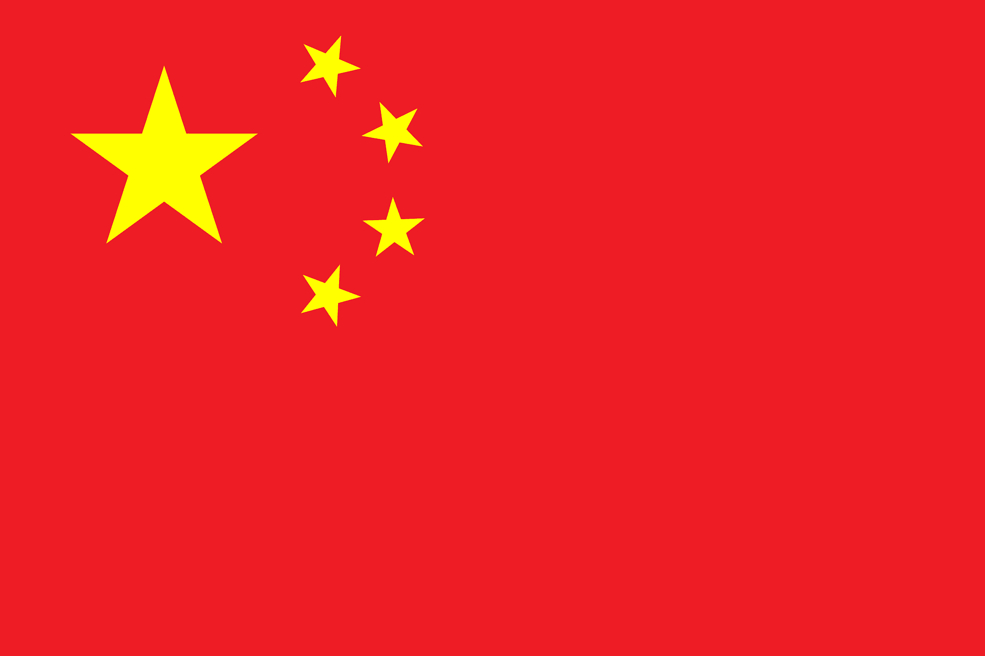CHINA
- Capital: Beijing
- Area: 9,596,961 sq km
- Population: 1.41 billion
- Languages: Mandarin Chinese, also Mongolian, Uyghur, Tibetan, Zhuang and others
- Religions: No Religion (52.2%) Indigenous Faiths (21.9%) Buddhist (18%)
- Christian (5%) Muslim (2%)
- Life expectancy: 74 years (men) 79 years (women)
- GDP per capita: 12,614 USD

Beijing

Key Water Stress and Supply Statistics
- Beijing is located in a water-scarce region and consistently faces water stress because demand approaches or exceeds renewable supply.

- Long-term structural scarcity exacerbated by rapid urban growth and climatic factors.

- Beijing is one of the world's most water-stressed cities, with per capita resources far below the international water poverty threshold.

- Total demand (3.6 billion m3) exceeds renewable resources (3 billion m3) forcing heavy reliance on overexploited groundwater and the South-to-North Water Transfer Project.

Water Sustainability and Management
- Over-exploitation of groundwater was significant, with rural water tables falling from above -20 meters before 2000 to much lower levels by 2012, though recent restoration projects have started to raise them.

- Since 2011, external water sources have accounted for the majority of the city's water demand.

- Large-scale engineering projects like the South–North Water Transfer Project play a central role in national strategy.

Climate and Risk Factors
- Since 1999, the city has experienced a continuous 10-year drought period with an average of only 480 mm/year of precipitation.

- In 2006, nearly half of China's major cities did not meet provincial drinking-water quality standards.

- The primary causes of water stress in the region are rapid population growth, industrial development, and climate change.

Your task is to secure funding for infrastructure improvements to Beijing’s water system.
You need £35 million.
UNITED KINGDOM
- Capital: London
- Area: 242,945 sq km
- Population: 67.7 million
- Languages: English, also Scots, Ulster Scots, Scottish Gaelic, Irish, Welsh, Cornish
- Religions: Christian (46.2%) No religion (37.2%) Muslim (6.5%) Hindu (1.7%)
- Life expectancy: 79 years (men) 83 years (women)
- GDP per capita: 49,463 USD

London

Key Water Stress and Supply Statistics
- Average daily water use per person in England is approximately 136.5 to 144 litres, which is significantly higher than government targets.

- Around 19% of water supplied in England is lost through leaks. Thames Water, serving most of London, reported losing over 600 million litres a day through leaks in 2022-23.

- Thames Water (serving 80% of Londoners) is considered "extremely stressed" with high debt, affecting its ability to invest in repairs.

- South London is particularly vulnerable, with groundwater reserves (providing 25% of the capital's supply) at risk of running low.

Water Sustainability and Management
- Hotter, drier summers and unpredictable weather patterns mean less rainfall to replenish water stocks.

- A shift toward smart water meters is underway to help pinpoint leaks, with roughly 12% of households in England equipped with them.

- Water companies are aiming to halve leakage by 2050.

- The Water Resources Southeast Plan includes proposals for new reservoirs and water recycling, according to the London Assembly.

Climate and Risk Factors
- The probability of needing to introduce severe, "day-zero" style water restrictions (like standpipes) is 1% annually, expected to reduce to 0.2% by 2040 with better management.

- A severe drought in London could cost the economy roughly £330 million per day.

- The Environment Agency estimates that 28% of underground water sources and 18% of surface waters are being extracted at unsustainable levels, damaging ecosystems.

Your task is to secure funding for infrastructure improvements to London’s water system.
You need £30 million.
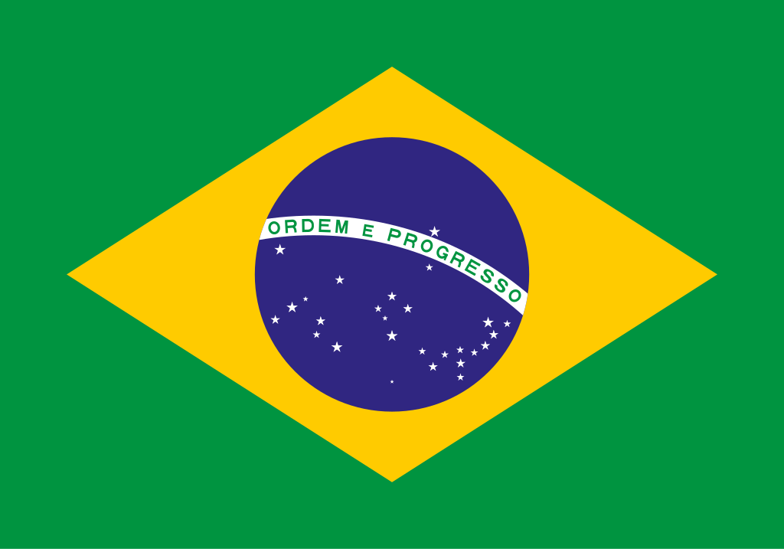BRAZIL
- Capital: Brasilia
- Area: 8,515,767 sq km
- Population: 217.2 million
- Language: Portuguese
- Religions: Catholic (57.6%) Protestant (26.9%) No Religion (9.3%)
- Life expectancy: 72 years (men) 79 years (women)
- GDP per capita: 10,580 USD

Sao Paulo

Key Water Stress and Supply Statistics
- São Paulo, Latin America's most populous urban area with 22 million people, is experiencing a severe, chronic water crisis driven by three consecutive years of below-average rainfall and low reservoir levels.

- As of late 2025, the key Cantareira system operated at less than 18% capacity, with some regions approaching only two weeks of water supply.

- Roughly 29% of water supply is lost through leaks in ageing infrastructure.

- The Cantareira system, which once supplied nearly half of the metropolitan area, now only serves about 25% of the population due to lowered capacity and improved, yet still insufficient, distribution.

Water Sustainability and Management
- To combat the scarcity, rationing has been implemented, saving over 57 billion litres of water, but high consumption and low input continue to strain supply.

Climate and Risk Factors
- The city suffered its worst drought in 2014, and current conditions are rapidly approaching that level of crisis.

- The watersheds supplying the system have lost over 70% of their original forest cover, accelerating sedimentation and decreasing storage capacity.

- High evaporation rates due to extreme heat, combined with low, erratic rainfall, have reduced water inflows.

- Water shortages are often more acute in peripheral, lower-income neighborhoods.

- With 50% of Brazil's energy coming from hydropower, low water levels also increase the risk of energy shortages.

Your task is to secure funding for emergency infrastructure repairs to keep Sao Paulo from ‘Day Zero’ in 2026 and a long term reforestation of the Cantareira System.
You need $45 million.
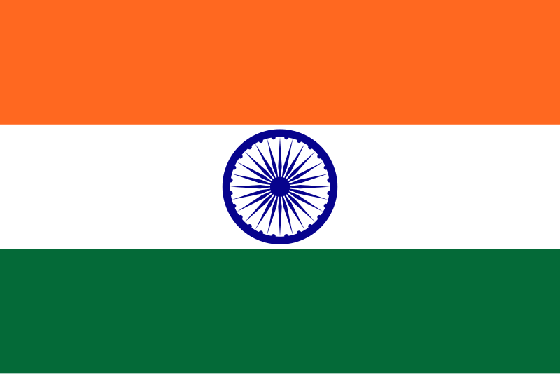INDIA
- Capital: New Delhi
- Area: 3,287,263 sq km
- Population: 1.44 billion
- Languages: Hindi, English, plus local languages
- Religions: Hindu (80%) Islam (14%) Christian (2%) Sikh (1.7%)
- Life expectancy: 68 years (men) 71 years (women)
- GDP per capita: 2,692 USD

Chennai

Key Water Stress and Supply Statistics
- Chennai has experienced acute water emergencies, notably in 2019 when all of its main reservoirs ran dry and “Day Zero” was declared — meaning nearly no potable water remained in municipal storage.

- Two consecutive poor monsoon seasons left reservoirs empty.

- Chennai faces severe water stress driven by over-exploitation of groundwater, where 46 out of 51 administrative blocks (firkas) are over-exploited.

- In late May 2024, reservoirs held only 42.28% of their total capacity, significantly lower than the 55% in the same period of the previous year.

- The city requires a huge volume, with domestic demand estimated around 400 million cubic meters per year.

Water Sustainability and Management
- To mitigate shortages, the city is using Tertiary Treatment Reverse Osmosis (TTRO) plants to recycle 20% of its sewage for industrial use.

Climate and Risk Factors
- The city is projected to grow to over 15 million by 2035, increasing pressure on already strained resources.

- 89% of residents have expressed concern about future water security, and the city is considered extremely vulnerable due to rapid population growth and climate change, with a projected 47% increase in population by 2035.

- Two consecutive years of poor, low rainfall or failed monsoon seasons frequently lead to the drying of the city's four main reservoirs.

- Increased frequency of extreme heatwaves in May and June elevates consumption and evaporation rates.

Your task is to secure funding for two more Tertiary Treatment Reverse Osmosis plants for Chennai. Each plant costs £30 million.
You need $60million.
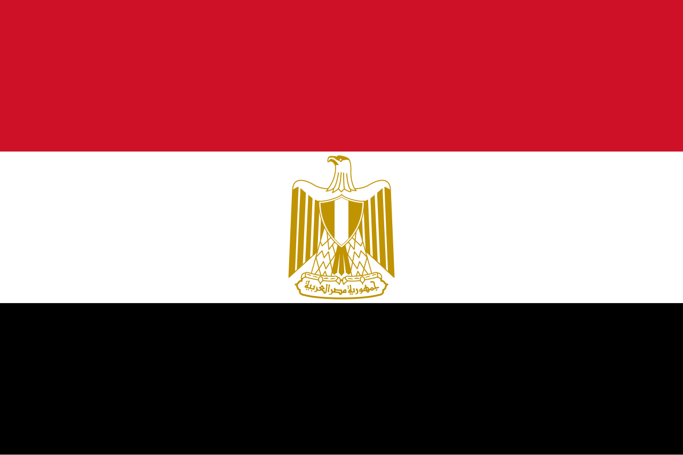EGYPT
Capital: Cairo
Area: 1,010,408 sq km
Population: 107.7 million
Language: Arabic
Religions: Muslim Sunni (90%) Christian (9%) Muslim Shia (1%)
Life expectancy: 69 years (men) 74 years (women)
GDP per capita: 3,570 USD

Cairo

Key Water Stress and Supply Statistics
- Egypt is one of the world’s most water-stressed countries, relying on the Nile River for over 90% of its freshwater.

- Agriculture consumes 80-85% of Egypt's water, the majority, while urban demand continues to rise.

- Per capita water availability is predicted to fall below 500 m³/year by around 2025 — a threshold referred to as absolute scarcity. Egypt faces an annual deficit of around seven billion cubic meters.

- Roughly 29% of water is considered "non-revenue" (leaks/unaccounted for).

Water Sustainability and Management
- 99.8% of treated water in Cairo meets WHO guidelines, with 96.6% of households connected to sewage systems.

- Increased reliance on wastewater treatment and stricter agricultural usage controls.

- Egypt operates around 100 desalination plants, producing 1.2 million m3 per day.

Climate and Risk Factors
- Population growth, climate change, and upstream developments threaten water security.

- Egypt's population is expected to reach 160 million by 2050, increasing demand.

- Nile water availability is limited, while climate change and upstream developments reduce reliable flows.

- Rising sea levels increase salt content in the Delta, while agricultural runoff and industrial waste pollute the Nile.

Your task is to secure funding for infrastructure improvements to Cairo’s water system.
You need $25 million.
INDONESIA
- Capital: Jakarta
- Area: 1,904,569 sq km
- Population: 275.7 million
- Languages: Indonesian, plus regional languages
- Religions: Muslim (87%) Christian (11%)
- Life expectancy: 68 years (men) 72 years (women)
GDP per capita: 4,876 USD

Jakarta

Key Water Stress and Supply Statistics
- Jakarta faces chronic water stress largely due to excessive groundwater extraction, which has both lowered water tables and caused land subsidence — a symptom of systemic overuse akin to water bankruptcy.

- Jakarta faces an "extremely high" baseline water stress score of 4 to 5 with over 80% of surface water withdrawn.

- Groundwater extraction drives severe land subsidence, with some areas sinking up to 25 cm per year. As a result, roughly 95% of North Jakarta could be submerged by 2050.

- Jakarta’s weak infrastructure means that 40-50% of water is lost through pipeline leakage.

Water Sustainability and Management
- Piped water coverage is stagnant at ~60-65% of the population, leaving 35% of residents dependent on wells.

Climate and Risk Factors
- Water demand in 2030 is expected to be 2.5 times higher than in 2000.

- As groundwater is depleted, seawater intrudes, contaminating, and forcing reliance on bottled water.

- 13 major rivers are heavily polluted with industrial/domestic waste.

- Urbanisation means that new high-rise buildings and factories heavily consume groundwater.

Your task is to secure emergency funding to both repair and extend the infrastructure of Jakarta’s water system.
You need £75 million.

IRAN
- Capital: Tehran
- Area: 1,648,195 sq km
- Population: 91.57 million
- Languages: Persian, Azeri, Kurdish
- Religions: Shi’a Muslim (90%) Sunni Muslim (9%)
- Life expectancy: 76 years (male) 78 (female)
- GDP per capita: 4,771 USD

Tehran

Key Water Stress and Supply Statistics
- Tehran is facing its most severe water crisis in a century, with officials describing the situation as a "near-apocalyptic" scenario, with some officials warning of potential evacuation if significant rainfall does not arrive.

- The crisis is driven by five to six consecutive years of drought, with 2024–2025 being one of the driest on record, reducing precipitation by 77-81% compared to long-term averages forcing heavy rationing and warnings about an imminent tipping point comparable to a “water bankruptcy.”

- Reservoirs supplying the capital have fallen to low levels (around 14% capacity reported), threatening agriculture and social stability.

- With surface water depleted, the city relies heavily on over-extracted aquifers. Parts of Tehran are subsiding by 24–25 cm per year due to this depletion, one of the highest rates in the world.

- Roughly 26% to 32% of urban water is lost through leaking pipes or theft

Water Sustainability and Management
- Officials have ordered usage cuts and implemented rationing to avert collapse.

- Water pressure has been reduced across the city, with reports of nighttime shutoffs.

Climate and Risk Factors
- Officials have warned that Tehran could face a ‘Day Zero’ complete shutdown of water supplies to certain areas if conservation efforts (aiming for a 20% reduction) do not succeed.

- Wealthier northern districts tend to have better access, while less affluent southern areas face more frequent rationing.
- The crisis is not just due to low rainfall, but chronic mismanagement, excessive agricultural water use (consuming 80-90% of the country's water), and high evaporation due to record heat (temperatures exceeding 50°C).

Your task is to secure funding to improve the infrastructure of Tehran’s water system.
You need £40 million.

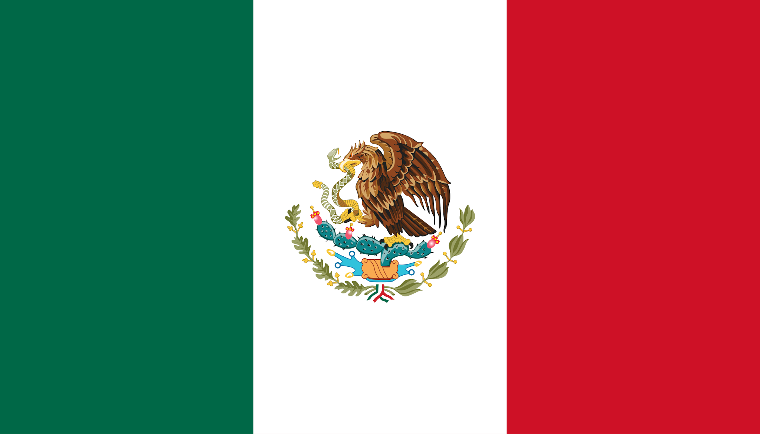MEXICO
- Capital: Mexico City
- Area: 1,972,550 sq km
- Population: 129.8 million
- Languages: Spanish, also Nahuatl, Yucatec Maya, Zapotec, Mixtec, Mayo, Yaqui, Tzeltal, Tzotzil, Chol, Totonac
- Religions: Catholic (77.8%) Protestant (11.7%) No Religion (8.4%)
- Life expectancy: 73 years (men) 78 years (women)
- GDP per capita: 14,157 USD

Mexico City

Key Water Stress and Supply Statistics
- Mexico faces water stress in central and northern regions, particularly Mexico City, due to over-extraction, aging infrastructure, pollution, and climate-driven droughts.

- Groundwater withdrawal has caused the city to sink at rates up to ~25 cm per year.

- About 17% of households in Mexico City experience moderate to severe water insecurity, with many neighborhoods facing weeks without water.

- 38%–42% of the water supply is lost to leaks in the distribution network.

- Of the 52 m³/s of residual water produced in the Valley of Mexico, only 6.1 m³/s is treated.

Water Sustainability and Management
- The critical Cutzamala reservoir system has historically dropped to critical levels (e.g., 26.7% in 2023, recovering slightly to ~53% in 2025).

- The government is implementing projects, including new dams and aqueducts, to manage the shortfall.

Climate and Risk Factors
- Reduced rainfall, prolonged droughts, and high temperatures are significantly lowering reservoir levels.

- The city was built on a lake bed, but rampant urbanization has reduced natural ground absorption and caused sinking, breaking pipe infrastructure.

- Without intervention, water stress will likely worsen, with 20 Mexican states projected to experience high water stress by 2050.

Your task is to secure funding for 3 new aqueducts for Mexico City. They each cost £15 million.
You need $45 million.
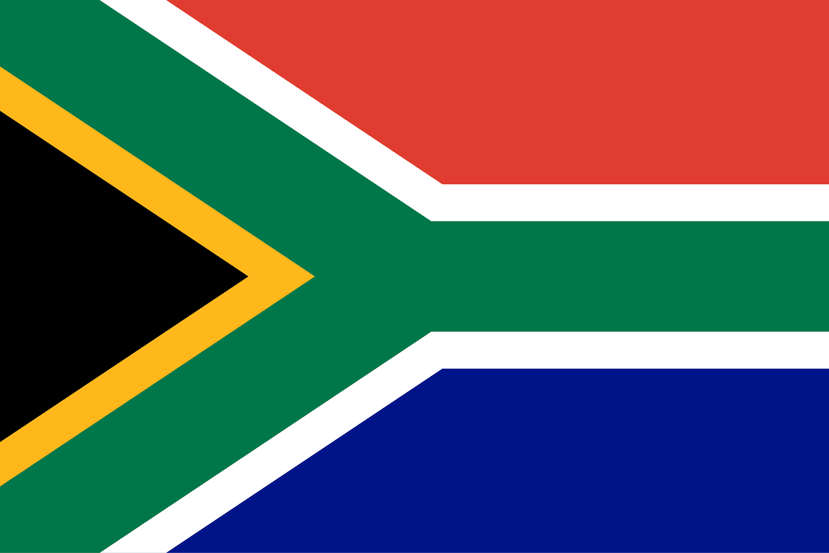SOUTH AFRICA
- Capital: Pretoria (executive), Cape Town (legislative), Bloemfontein (judicial)
- Area: 1,221,037 sq km
- Population: 62.02 million
- Languages: Zulu, Xhosa, Afrikaans, English, Sepedi, Swazi, Sesotho, Setswana, Xitsonga, Tshivenda, Ndebele
- Religions: Christian (85.3%) Indigenous Faiths (7.8%) No religion (3.1%) Muslim (1.6%) Hindu (1.1%)
- Life expectancy: 60 years (men) 67 years (women)
- GDP per capita: 6,022 USD

Cape Town

Key Water Stress and Supply Statistics
- Between 2015 and 2018, Cape Town faced a severe, 1-in-400-year drought. The city came within weeks of losing municipal water supply when dam levels fell to just 13.5% of capacity, narrowly avoiding "Day Zero" (when taps would turn off).

- Dam levels dropped to about 14–29 % of capacity during the peak of the crisis. Strong conservation actions averted complete cutoff.

- The largest storage reservoir, Theewaterskloof Dam, fell below 10% capacity, making extraction difficult.

Water Sustainability and Management
- Strict consumption limits reduced usage to 50 liters per person/day, with formal households using 66% of water, while informal settlements used just 4%.

- Mandatory, aggressive water restrictions saw daily consumption drop from over 1,200 million liters per day to roughly 500 million liters, a ~50% reduction in city-wide usage.

- By 2022, dam levels recovered to over 95%, thanks to improved rainfall and, to a lesser extent, increased diversification of supply.

- The city has continued to focus on long-term resilience, prioritizing groundwater sources like the Cape Flats aquifer.

Climate and Risk Factors
- The city depends heavily on six main dams, leaving it vulnerable when winter rains fail.

- Invasive plant species (e.g., pine, wattle) in catchment areas consume significant water, reducing runoff into reservoirs.

- A growing population increases overall water demand, stressing the supply system.

- Inadequate infrastructure and reliance on a single, weather-dependent supply system increase risk.

Your task is to secure funding to build a desalination plant in Cape Town to diversify sources of water.
You need £30 million.
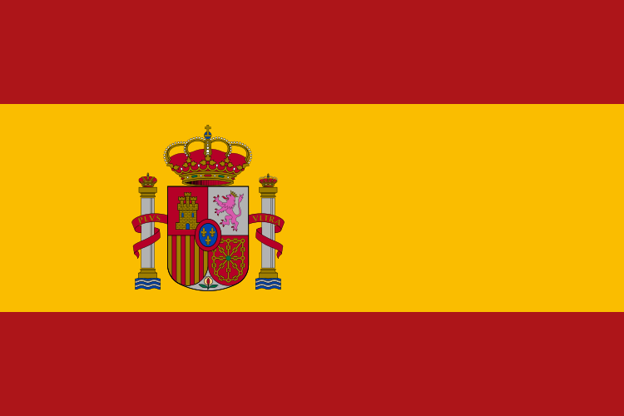SPAIN
- Capital: Madrid
- Area: 505,990 sq km
- Population: 47.1 million
- Language: Spanish
- Religions: Catholic (55%) No Religion (39%) Muslim (2.76%)
- Life expectancy: 79 years (men) 85 years (women)
- GDP per capita: 34,500 USD
Madrid

Key Water Stress and Supply Statistics
- Madrid is classified in global assessments as a city with high water stress due to regional climate patterns and seasonal demand pressures.

- Madrid has a 20% chance of droughts in the coming 10 years.

- Madrid is overly reliant on the Tagus River basin (River Tajo) which provides nearly 50% of its water supply.

- The urban region of Madrid has experienced high, though reducing, water consumption, with some studies highlighting the need for increased water efficiency in the city’s network.

- Despite scarcity, Madrid maintains high tap water quality, with less than 1% of the supply affected by significant contamination in recent years.

- As of mid-August 2025, Spain's reservoirs were at a critical average level of 63.9%, highlighting the precarious nature of water supplies during summer months.

Water Sustainability and Management
- The European Investment Bank is involved in projects aimed at upgrading water and wastewater infrastructure in Madrid.

- Studies suggest that nationwide, Spain must significantly increase investment in water management, with projections calling for at least 6 billion euros annually over the next decade.

Climate and Risk Factors
- Climate change intensifies droughts, while agriculture and tourism increase seasonal demand.

- By 2050, water stress in Spain is projected to worsen significantly, with many regions expected to face high to extremely high, or "severe," water stress.

- Southern Europe drought patterns intensify seasonal shortages.

Your task is to secure funding for infrastructure improvements for Madrid’s water system.
You need $25 million.
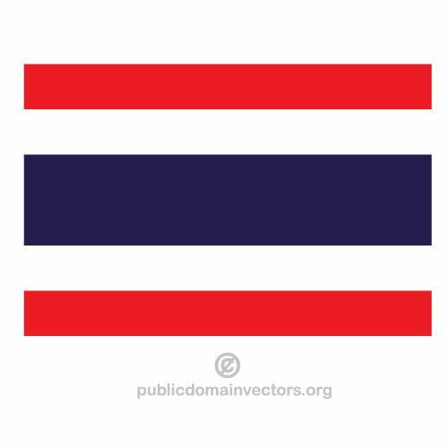THAILAND
- Capital: Bangkok
- Area: 513,120 sq km
- Population: 65.9 million
- Language: Thai
- Religions: Buddhist (90%) Muslim (7%) Christian (1.2%)
- Life expectancy: 75 years (men) 83 years (women)
- GDP per capita: 7,347 USD

Bangkok

Key Water Stress and Supply Statistics
- Bangkok is listed among cities with high water stress, driven by rapid urban growth and competing demands between urban and agricultural uses.

- Bangkok faces a dual water crisis of moderate-to-high water scarcity and extreme flood vulnerability.

- Relative sea level rise of 17 mm per year is recorded near Bangkok.

- Approximately 18.6% to 23.2% of surveyed residents in Bangkok reported water insecurity in recent studies.

Water Sustainability and Management
- Saltwater intrusion affects coastal areas, with shorelines receding by over 20 meters annually in some parts.

- Industrial areas are building large reservoirs and implementing water recycling/reuse systems to manage drought.

- A 41-hectare park with wetlands and ponds has been built to retain 87 million litres (23 million gallons) of storm runoff.

Climate and Risk Factors
- Climate change causes more intense, concentrated rainy seasons and longer, hotter dry seasons.

- The city is sinking at 1-4 cm per year, while the Gulf of Thailand rises 1-4 mm per year.

- Bangkok faces a 20% chance of severe drought in the next 10 years, coupled with 96% of the city potentially falling below sea level by 2030.

Your task is to secure funding for another wetlands project in Bangkok.
You need $15 million.

